User Guide for Health InsuranceMGMT System

Welcome to HealthInsuranceMGMT System!

This guide will help you get the system up and running on your PC and provide you with the basic steps to start using it.

System Requirements:

To ensure the HealthInsuranceMGMT system runs smoothly on your PC, you'll need the following:

Operating System: Windows 10 or later, MacOS Mojave or later

Processor: Minimum Dual Core 2.4 GHz or equivalent

Memory: 4 GB RAM or higher

Storage: At least 500 MB of free space

.NET Core Runtime: Version 6.7 or later

Visual Studio 2022 or later

Internet Connection: Broadband connection for online functionalities

Browser: Latest version of Google Chrome, Firefox, or Edge

Installation Process:

Download the HealthInsuranceMGMT setup file from the GitHub Repository   
 From this Link:  
https://github.com/Zaayan325/Health_Insurance_MGMT

Double-click the setup file to start the installation.

Then Rebuild the Project for the Nugget Packages

Then go to appsettings.json and paste your connection String there

Then run the command on the nugget package manager add-migration AddAllToDatabase

Then after Creating a Migration write a line update-database

Once installed, launch the program via the desktop shortcut or start menu.

First-Time Setup:

Upon launching, you will be greeted with a home screen:  
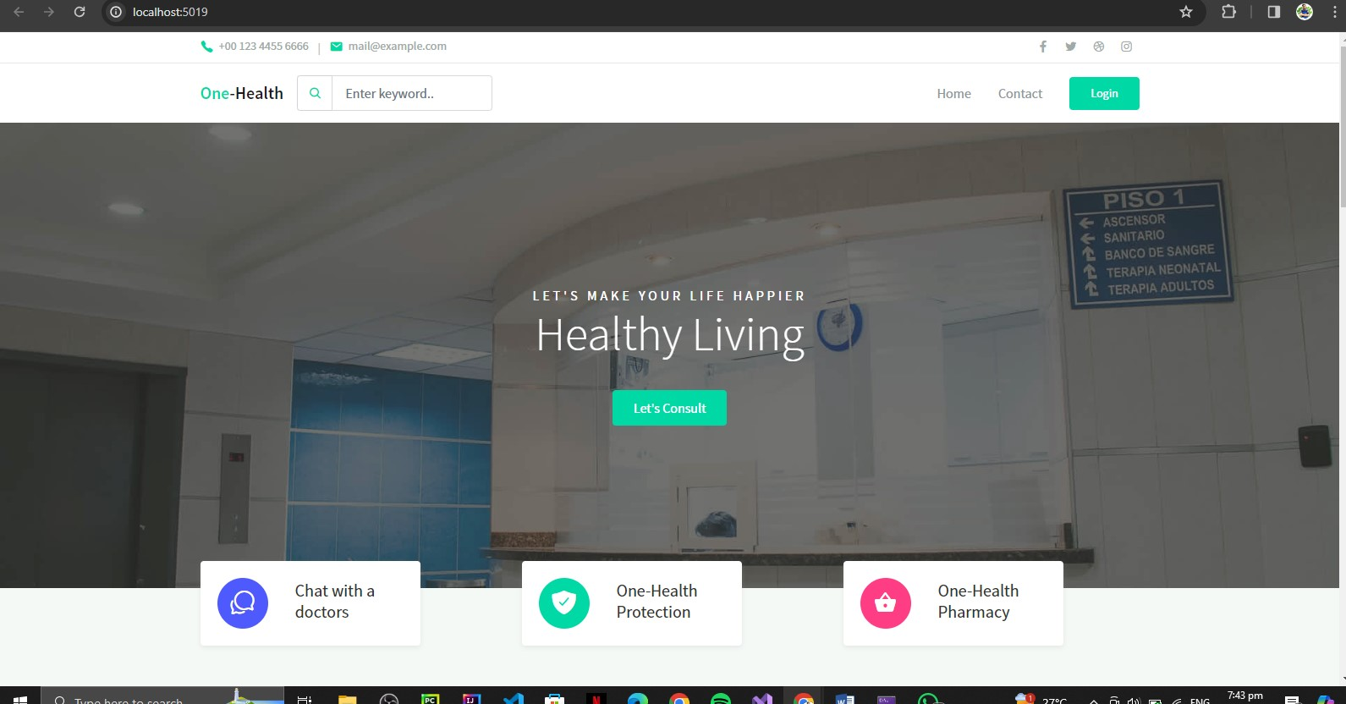

Enter the username and password provided to you by the system administrator in the login page.

New users may need to register; click on the ‘Login’button and fill in the required details.

Navigating the System:

Employee Login :  
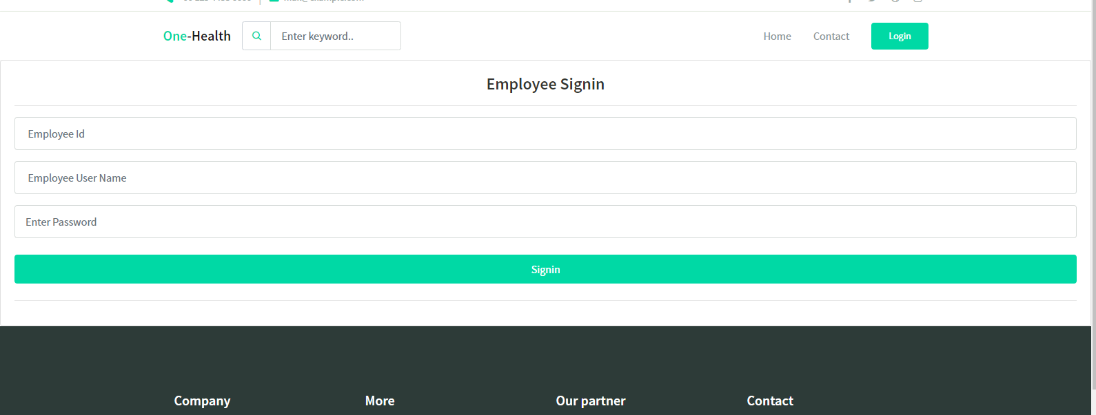

Employee Dashboard: Here, you will find a summary of your details and actions you can perform.

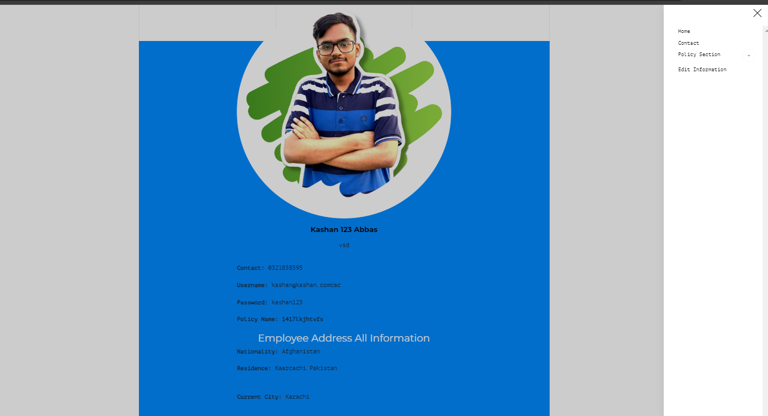

Employee Edit Information Page  
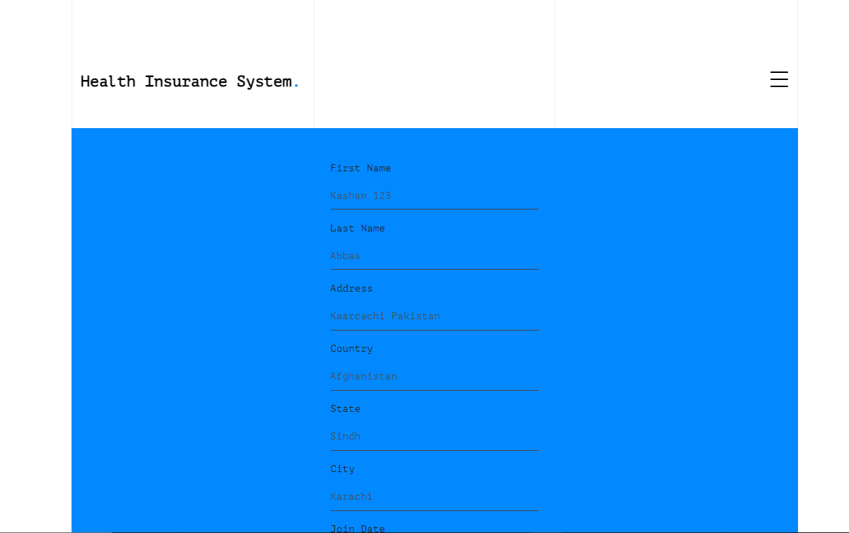

Support from Employees Screen:

If you encounter any issues or need assistance, please contact the IT support team to Admin

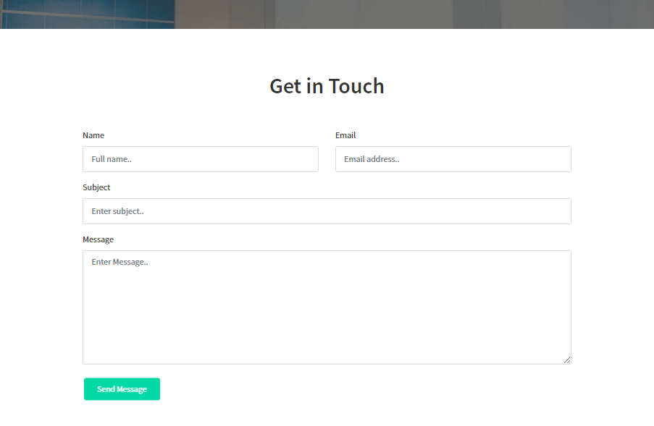

For Requesting The Policy

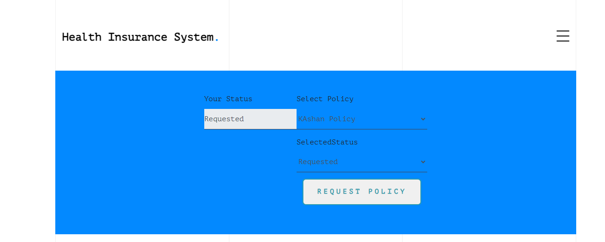

For Checking an Downloading All the Policies By Employee  
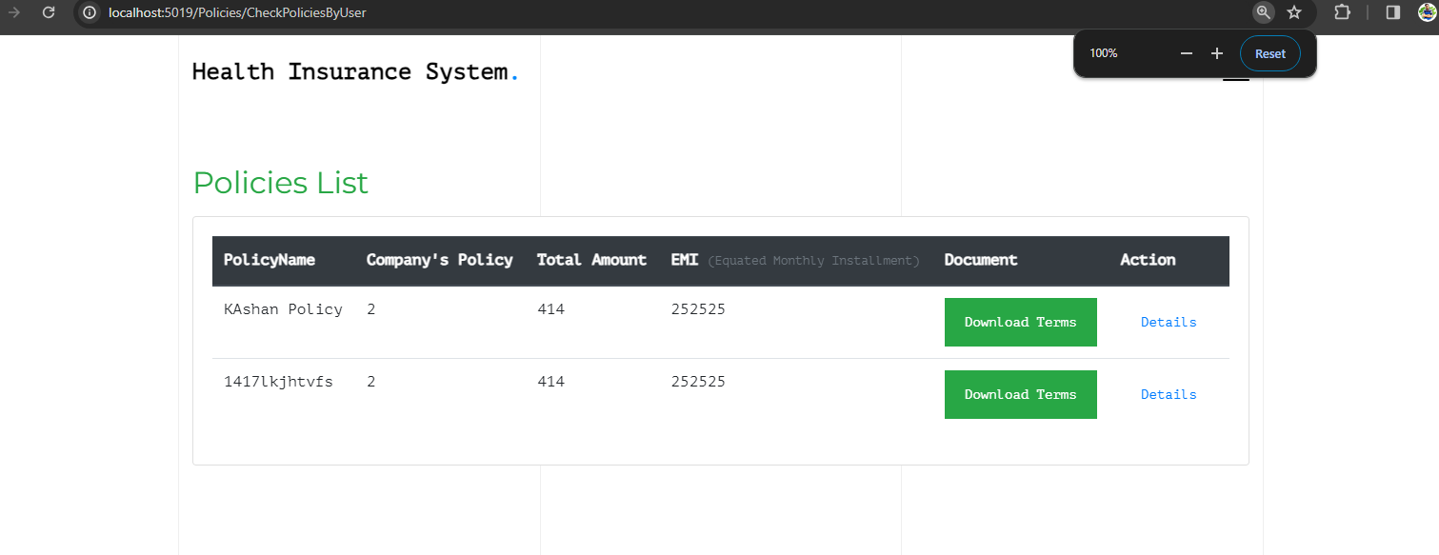

Thank you for choosing HealthInsuranceMGMT!